Oozie runs spark jobs. To trigger a job use shell script

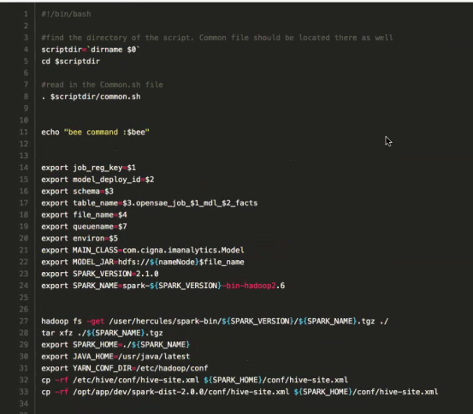

$ signs are parameters that is passed in from oozie

spark submit script can be directed generated from Cloudera Manager

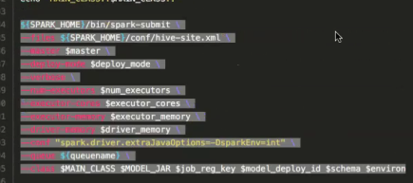

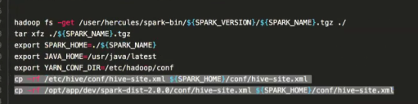

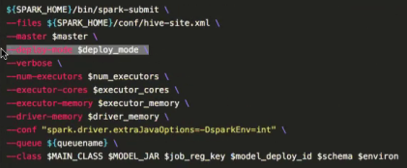

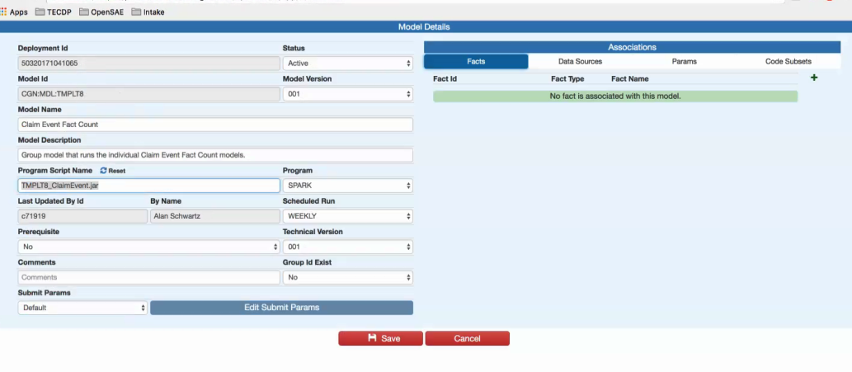

if spark job fails:

